Tea Trip to Malawi with Satemwa Tea Estate and ITMA

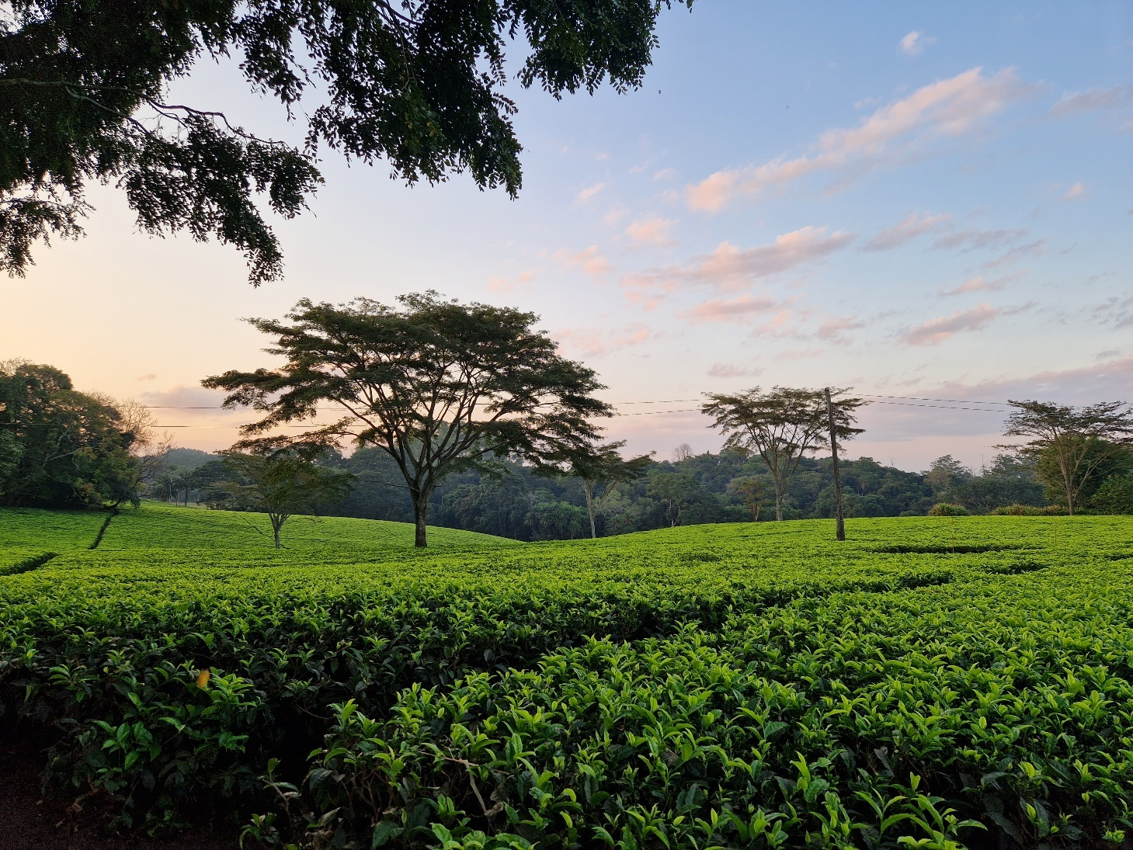

Dive deep into the world of tea with an unparalleled adventure in Malawi's pristine tea landscapes at Satemwa Tea Estate, in collaboration with the International Tea Masters Association (ITMA).

Here, theory meets practice. While ITMA provides a structured and rigorous theoretical foundation about teas from around the world, Satemwa brings these lessons to life. Traverse the lush fields, from young tea plants to mature bushes, ready for plucking. Experience firsthand the transformation of fresh tea leaves into exquisite white, green, oolong, black, and dark teas. Explore the diverse tea varieties and cultivars, and understand their unique profiles and significance.

Beyond just tea crafting, this journey illuminates the broader canvas — the social and environmental dynamics that influence these tea communities. Immerse yourself in the rhythms of life on a tea estate, nestled amidst the rolling green, and engage in enlightening tea dialogues with experts, steeped in three generations of passion.

Concluding your journey, the ultimate reward awaits: Craft your own tea blend, a memento of your Malawian tea adventure and the amalgamation of ITMA's knowledge with Satemwa's rich heritage.

Join us June 2024, and weave your own tea story, where global tea knowledge beautifully intertwines with local tea artistry.

Timing : 23th of June – 28th of June

Full Program

Pre Travel : ITMA e-learning course what is a tea sommelier, tea utensils.

Arrive on Sunday : get to know each other and introduction of the program

- Monday:
  - Visit a tea nursery: importance of natural compost, tea rooting systems, varieties
  - Good agricultural practices: pest management, pruning, irrigation, uprooting,…
  - Visit small holder tea fields – learn more about 7 day plucking rounds
  - Meet plucking gangs for CTC & specialty orthodox tea – what is the difference?
  - Theoretical part on tea processing techniques – factory class room – by ITMA.
  - Practical part on tea processing techniques: withering room + rolling machines + steamers + drier.

- Tuesday:
  - 07:30 am: Specialty tea plucking workshop – you learn how to pluck your own fresh green tea leaves in a tea field. You pluck different cultivars.
  - Weighing your green leaf and up to the withering area in the factory.
  - Tea cupping at the Satemwa cupping room
  - Visit to the Tea Research Foundation of Central Africa (TRFCA) in Mulanje. When science meets tea. Learn about the history of this institute and its importance for the global tea industry. Find out the difference between the agronomy and botanical research approach. Learn about tea cultivars, tea varieties and their characteristics. Discover their tea gene bank and understand about how bee populations help the tea science in Malawi!

- Wednesday:
  - Part 1 – 2.5 hours
    - Specialty Tea Processing workshop – you will play around with green, semi oxidized and black processing techniques. You will get explanations how to handle the different tea crafting machines. Ball rollers, micro driers,…
    - You learn about defaults and defects and how these could influence the taste and flavor.
    - You will taste your own tea during the different processing steps to understand what certain processes are doing with the taste.
    - You will understand the importance for hand sorting & grading.
    - You will go home with your own freshly handmade teas.
  - Visit to the Satemwa school – class rooms – nursery.
  - Visit the Satemwa Clinic and some Fair Trade projects.
  - Part 2: history of tea, Japanese tea, herbals by ITMA

- Thursday:
  - Part 1 (optional)
    - Start Satemwa Coffee Tour on foot.
    - Visit the coffee washing station – learn about arabica coffee, coffee picking, different processing methods, about fermentation, drying beds, coffee fruit / cascara,…
    - See how coffee & tea interact on Satemwa.
    - Coffee cupping / tasting
  - Part 2: ITMA – Chinese teas + tasting by ITMA
  - Part 3 : what’s next for people interested in ITMA tea sommelier certification program

Post Travel : e-learning on tea and health + e-learning on world tea market insights by ITMA

Flights &Visa
Ethiopian Airlines offers convenient routes to Blantyre International Airport (BLZ). For travelers from Europe, anticipate a budget of approximately 1000 euro for a round-trip ticket in economy class (between 1500 – 2000 EUR if you travel from outside Europe), which attendees will need to book themselves.

While previously, tourists had to secure a VISA to enter Malawi, this mandate has been recently waived. Should a VISA become necessary again, it's the responsibility of the participant to obtain it.

Accomodation
There are two distinct accommodation options available on the estate, subject to availability, with payments to be made directly to Satemwa in Malawi:
- Huntingdon House: Boasting 5 upscale rooms, a special rate of 185 euro per person per night on a full board basis is available for this event.
- Chawani Bungalow: A more intimate setting reminiscent of a tea family home, this bungalow offers 4 rooms, a spacious patio, and a swimming pool. It's the perfect spot for aficionados to bond over their favorite brew. A special rate for this event is set at 135 euro per person per night for single room occupancy. If opting for shared accommodation, the cost is 115 euro per person per night, inclusive of full board.

Transport in Malawi
- Airport transfer: Blantyre Airport to Satemwa (+/- 1 hour): 50 euro per person per trip – to be arranged in advance.
- On the estate – free to walk – several indicated walks on Satemwa. Little maps are available.
- During the tea education modules – all transport is included.
- Before and after the tea education modules – transport can be arranged via a local travel
agency by the participant.

Food & Drinks
- Breakfast: eggs, toast, cereal, yoghurt and fruit. Water, tea & coffee included
- Lunch: 2 course meal – water, tea & coffee included
- Diner: 3 course meal – water, tea & coffee included.
- Soft drinks, beer and wine will be available – we will use a honesty tap system.

Trip before & after Covid
- Best to check latest regulations on testing & vaccination with the airlines prior to arrival in
Malawi. Other useful info can be found via: https://www.facebook.com/malawimoh

Booking & Payment

Contact Stijn Van Schoonlandt at stijn@kruze.be who will be your ITMA instructor during this event for booking & payment.

